Hands on Health Australia
Aboriginal Health in Aboriginal Hands (AHAHA) Pop Up Clinic at the
Ballarat Koorie Football Carnival

On Saturday 12th and 13th of October, the HoHA Pop Up Clinic in partnership with RMIT University’s
Chiropractic Students and Supervisors gathered to participate in the Ballarat Koorie Football Carnival.

This was the fifth year in which chiropractic students, supervised by clinical supervisors have participated in the carnival, which represents the largest gathering of Aboriginal people in Victoria.

April Clarke, Director, Aboriginal Health in Aboriginal Hands for HoHA, summarised the HoHA Clinic located at the Fitzroy Stars and the Pop Up Clinic at the Koorie Carnival as “reconciliation in action”.

Stephanie Pelz, Fourth Year Chiropractic student described her experience as:
“truly one of the best experiences during my time at RMIT. Being amongst such a vibrant welcoming atmosphere was such a bonus on top of learning so much about chiropractic and also building relationships of trust and goodwill in the community. I am extremely grateful for my opportunity at the Fitzroy Stars and couldn`t recommend it enough for others”.

Fraser Carson, Fourth Year Chiropractic student, reflected that:
“ The Koorie carnival was a great experience surrounded by great people. It was amazing to see the camaraderie and sense of family between competing teams. On the field, the competition was fierce, but afterwards, in and around the treatment tent, everyone was laughing and communicating with one another like the family that they are. The treatment experience was secondary to the people. A great weekend for all”.

Thanks to April for organsing the HoHA Pop Up Clinic again this year with RMIT Students, and to Dein Vindigni, Sam Harman and Georgie Cogan who volunteered their time as clinical supervisors over the weekend.

Below Stephanie Pelz
Treats a player at the
HOHA Pop Up Clinic The HoHA Pop Up Clinic after Saturday`s events at the Carnival
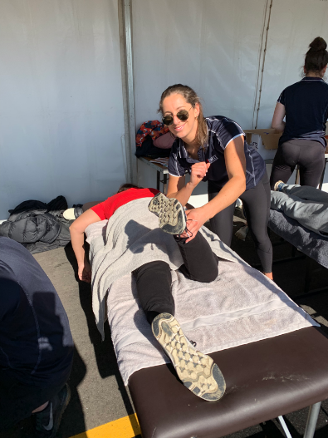
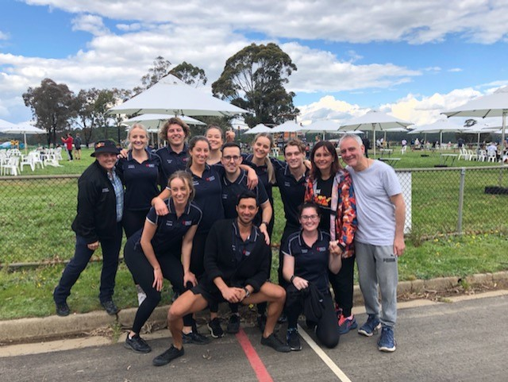

HANDS ON HEALTH AUSTRALIA – ENDS 18TH October, 2019. ©

